Scouting Safety is based on
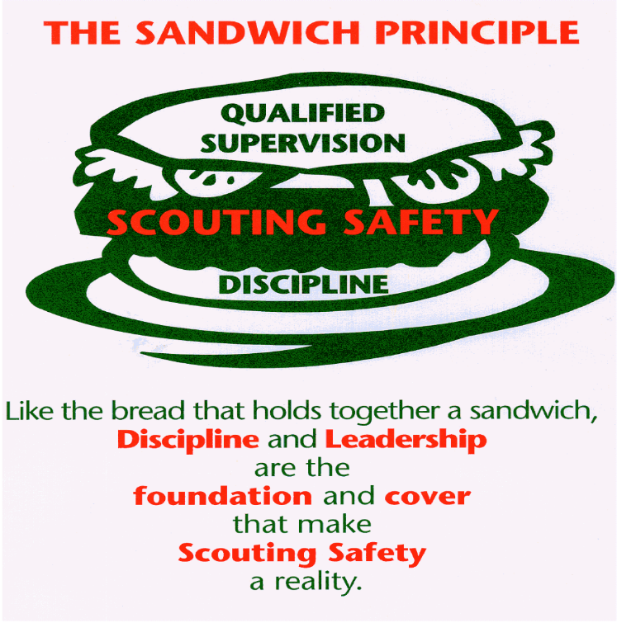
Look back at the Sweet Sixteen list and check out what 31 and #16 (the first and the last) are.
Everything is else is what you need to do to keep Scouts safe for a specific activity. Discipline and Leadership are what make everything else work.

